Lab 9

By Hoda Malak

Map options and layers Map options
Q1: Create a bmp image file from sheet2, containing a meaningful title and caption, and insert it into your document.
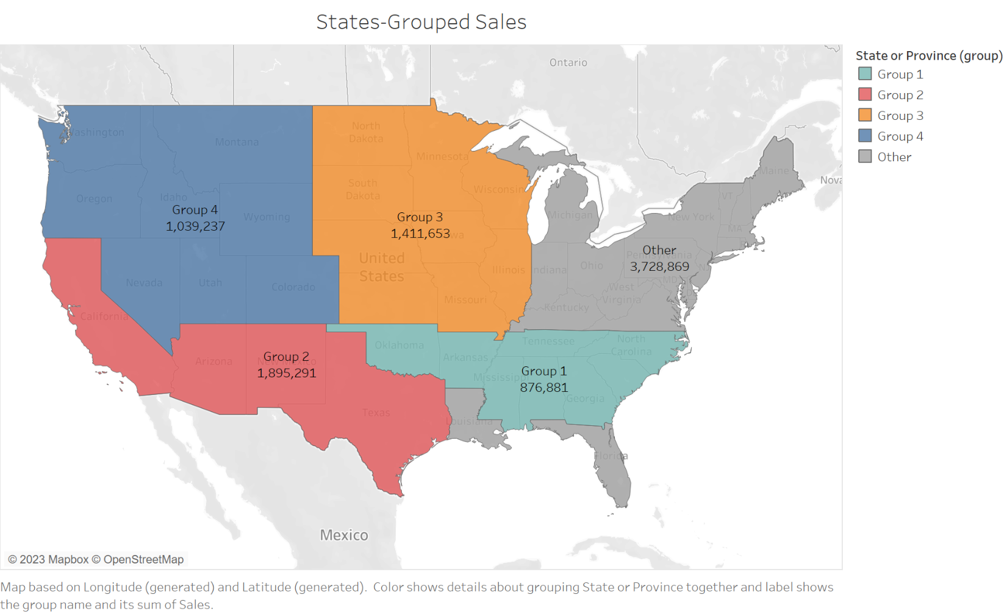

Custom geocoding Custom geocoding
Q2: Create a bmp image file from sheet3, containing a meaningful title and caption, and insert it into your document.
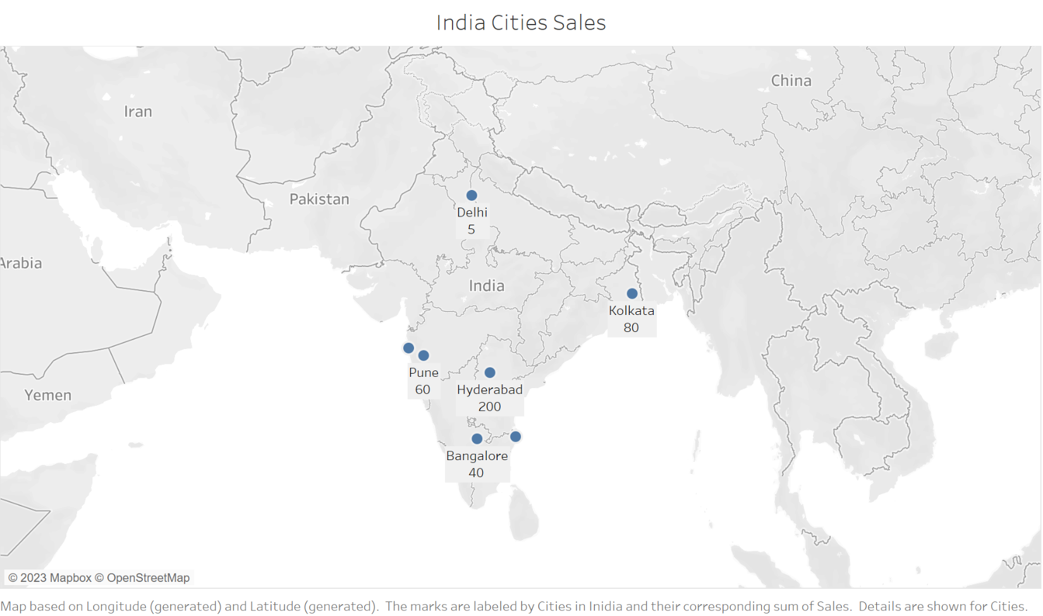
Q3: Create a bmp image file from sheet4, containing a meaningful title and caption, and insert it into your document.
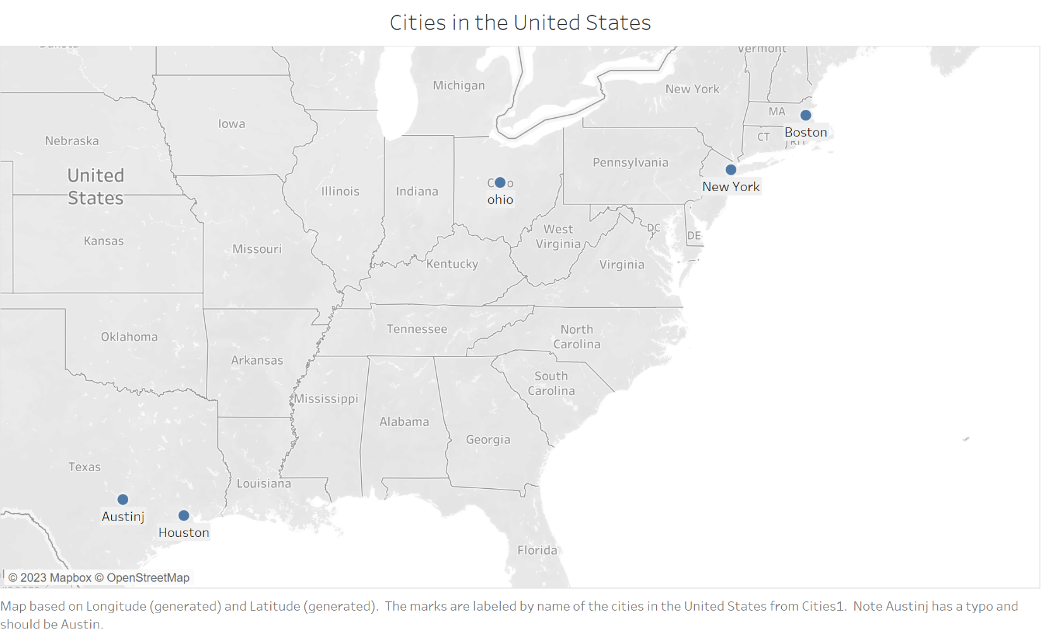

Religion wise population
Q4: Create a bmp image file from sheet5, containing a meaningful title and caption, and insert it into your document.
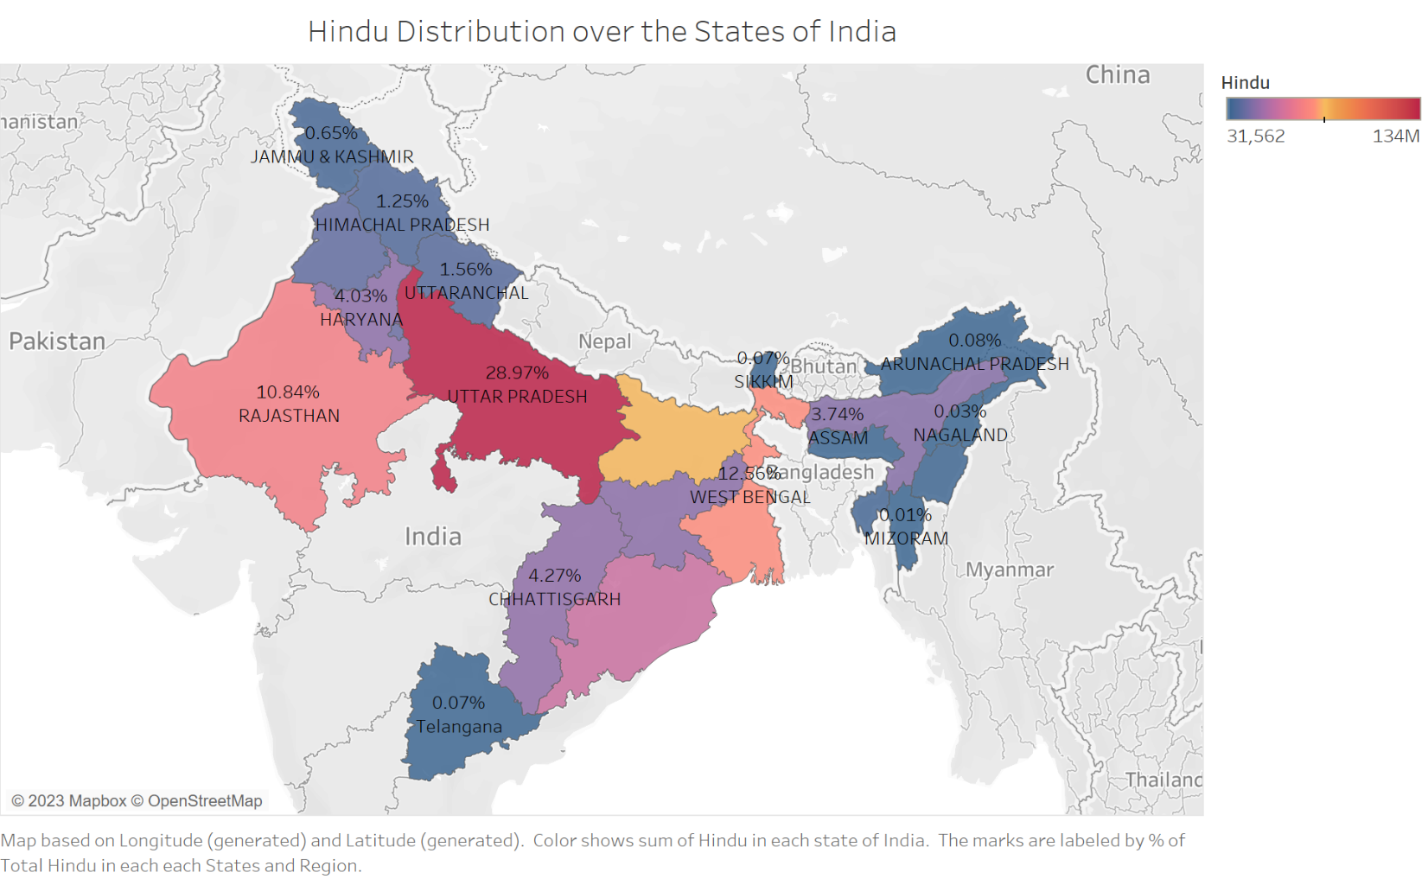
Q5: What percentage of Hindus live in Rajasthan state?
The percentage of Hindus who live in Rajasthan state is 10.84% .

Q6: Create a bmp image file from sheet6, containing a meaningful title and caption, and insert it into your document.
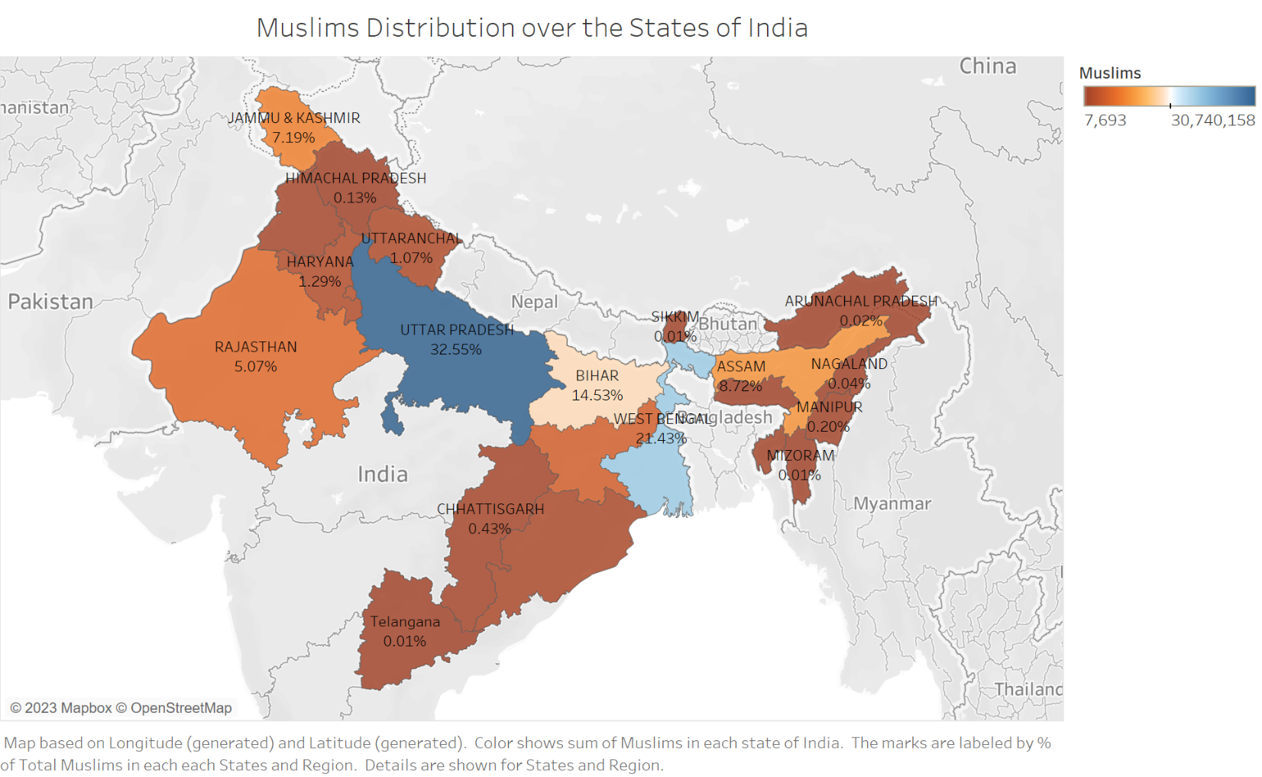
Q7: In which state 14.53% of Muslims live?
14.53% of Muslims live in the State of Bihar.

Vehicle Registration State Wise
Q8: Create a bmp image file from sheet7, containing a meaningful title and caption, and insert it into your document.
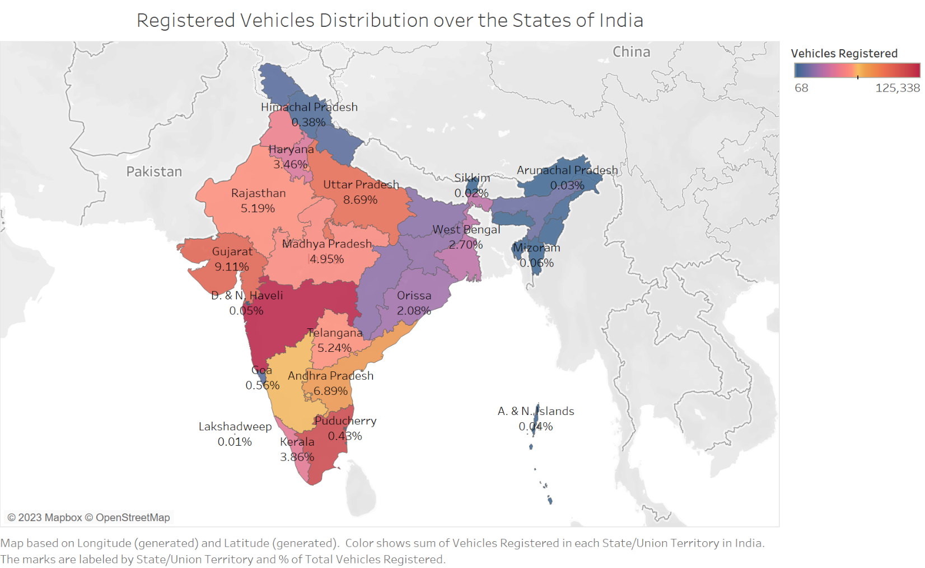
Q9: Which state registered the highest percentage of vehicles? What is the percentage?
The state that registered the highest percentage of vehicles is Maharashtra, and the percentage of vehicles registered in this state is 11.74%.
Q10: What is the percentage of vehicles registered in Jammu & Kashmir?
The percentage of vehicles registered in Jammu & Kashmir is 0.57%.

